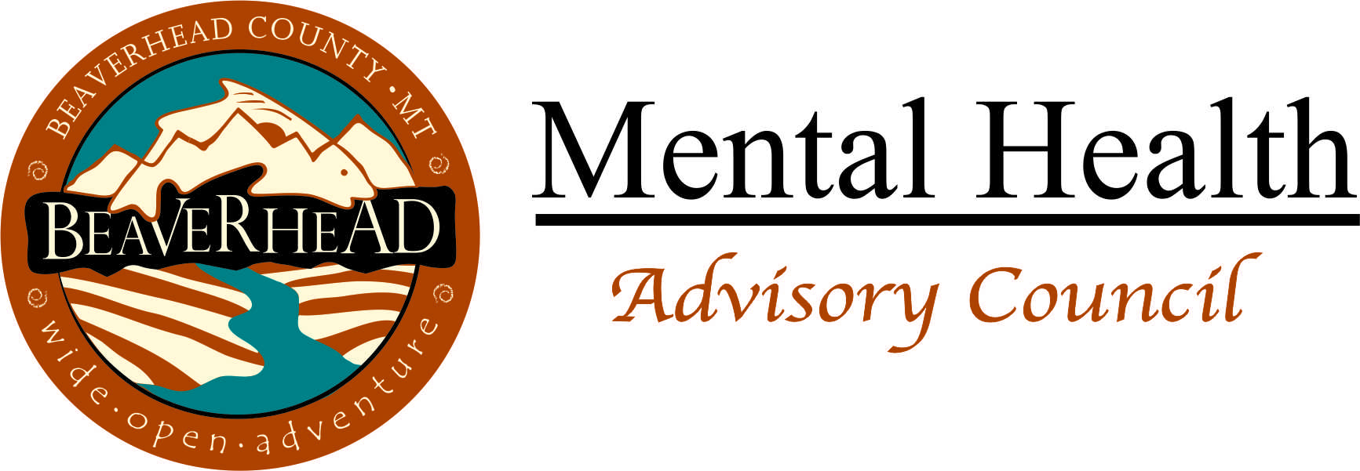

MENTAL HEALTH SERVICES SURVEY
UPDATE APRIL 2018

In December 2017, a series of state budget reductions in mental health care services resulted in the closure of the Western Montana Mental Health Center in Dillon and impacted other mental health services in southwest Montana. In January 2018, additional statewide budget cuts caused the Beaverhead Office of Public Assistance closure. In response to these changes, the Beaverhead County Mental Health Local Advisory Council (LAC) created this survey to identify which SPECIFIC general assistance and mental health services are/were most valuable to our community and what kind of issue(s) their loss/reduction caused.

These questions are the first step to define specific issues as we look for possible resolutions. Our community response will likely look different from prior services. Your comment(s) on which services are most important is critical. Return the survey by APRIL 16, 2018 to LAC member Katherine Buckley-Patton at:

- Email/Scan: gaelicgrannie@gmail.com OR
- Mail: 830 E Parkview Court, Dillon, 59725 OR
- Drop off to: Jamie Flynn/Beaverhead County Courthouse/2nd floor

KEY INFORMANT QUESTIONS

1. What essential public service(s) has our community lost? What’s missing that is still/now needed? (What specific service is most valuable to you or your family? Why? What do you need help with now OR what isn’t easily accessible that causes hardship?)

2. What specific mental health services are/were most valuable? Why? (Broad responses, such as “targeted case management”, are not as helpful as a detailed example(s) of how certain services are most important.)

3. Who is at risk with the loss of these services? Is there a particular group or individuals who are now most vulnerable? Who? Why? (What is something important...be specific... you may not get done due to losing these services? What kind of problems/challenges does that cause you or your family?)

4. How many individuals in your family are affected by these changes? Are there certain ‘groups’ you know are particularly struggling? (How many individuals do you know who are struggling due to the offices’ closures, services reduction, or budget cuts? What kind of challenges do they have?)

5. Is there someone else who you can speak to these issues? Please take an extra copy of this survey and give it to them. Contact Katherine to email or mail a copy to someone.

***Please use the back of this form if more space is needed to answer questions.***

Thank you for your participation.
Responses are due no later than April 16, 2018.

