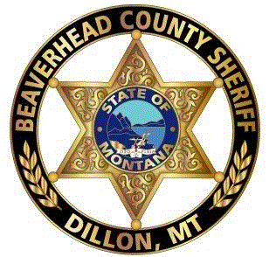

CIT Academy
Registration Form

CIT Academy # 14
March 11-15, 2019
Swysgood Techology Center
UMW Campus Dillon MT 59725

Name:
Email:
Best Address:
Best Telephone #:
Mobile Phone #:
Mailing Address:
City: State: Zip:
Rank / Title:
Job Function:
Field of work:
CIT Region:
ID/Badge #: Date of Hire:
Agency: Birthdate:

Tuition: $125.00

Please make tuition payable to: Beaverhead County Sheriff’s Office
Mail tuition to:
Beaverhead County Sheriff’s Office
Attn: Deputy Bill Knox
2 S Pacific St CL#16
Dillon, Montana 59725

This form must be completed and received by the CIT Coordinator by:
4:00 p.m. on Monday March 4, 2019

